|  |  |
| --- | --- |
|  | **NATIONAL INSTITUTE OF TECHNOLOGY PUDUCHERRY**  **Karaikal – 609 609.**  **NSS Unit** |

**Report on Leap Programme Inauguration**

NITPY has initiated a new programme named “LEAP” for Government and Private school students to crack JEE Examination and the programme Inauguration Ceremony was conducted at Danal Thangavel Mandapam Karaikal on 7.01.2019 at 5.00 to 7.30PM. Students, Parents, Faculties of NITPY were attended the Inauguration Ceremony.

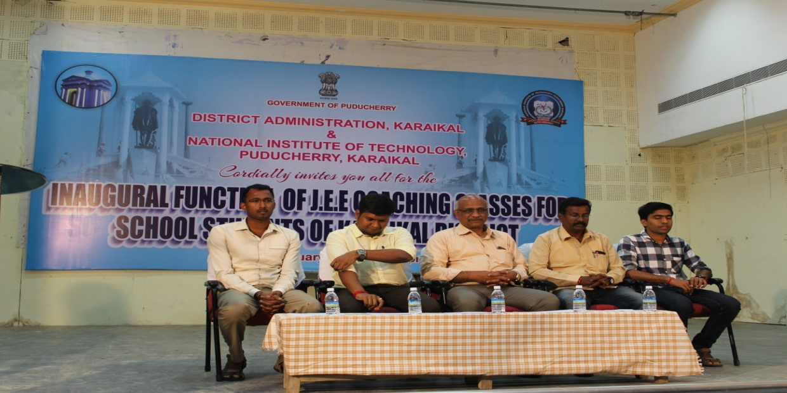

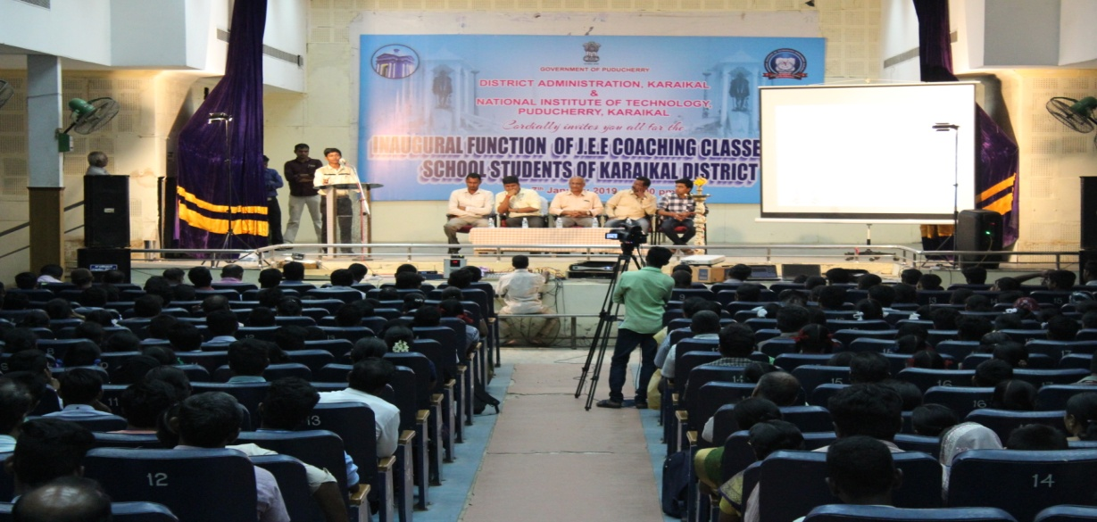

**Dr. V. Govindaraj**

**NSS Programme Officer, NIT-PY**

Copy to

1. Office File.